A Synopsis Report

on

**Responsive Blog Website**

Submitted to the Department of Computer Science and Engineering

In partial fulfilment of the requirements

For the degree of

Bachelor of Technology

in

Computer Science and Engineering

by

Deepanshu

(2100140100031)

**Group No. 3**

Guided By

Ms. Anubha Dhaka

(Assistant Professor)



Department of Computer Science and Engineering

**Shri Ram Murti Smarak College of Engineering & Technology, Bareilly**

**Dr. A.P.J. Abdul Kalam Technical University, Lucknow**

15th July, 2023

# TABLE OF CONTENTS

Acknowledgement 3

Abstract………………………………………………………[4]

1. Introduction of Project……………………………………….[5]
   1. Motivation…………………………………………[5]
2. Problem Statement……………………………………………[5-6]
3. Literature Review ……………………………………………[6]
4. Methodology ………………………………………………...[6-7]
5. Technology Used …………………………………………….[7-8]
6. Requirement and Specifications……………………………...[8]
7. References……………………………………………………[9]

**Acknowledgement**

It gives us a great sense of pleasure to present the synopsis of the B.Tech. Project undertaken during B.Tech. Second Year. We owe special debt of gratitude to Ms. Anubha Dhaka, Assistant Professor, Computer Science and Engineering, S.R.M.S. C.E.T, Bareilly for her constant support and guidance through out the course of our work. Her sincerity, thoroughness and perseverance have been a constant source of inspiration for us. It is only her cognizant efforts that our endeavors have seen light of the day.

We also take the opportunity to acknowledge the contribution of Er. Hiresh Kumar Gupta, Head Department of computer science & Engineering, S.R.M.S. C.E.T, Bareilly, for his full support and assistance during the development of the project. We also do not like to miss the opportunity to acknowledge the contribution of all faculty members of the department for their kind assistance and cooperation during the progress of our project. Last but not the least, we acknowledge our friends for their contribution in the completion of the project.

Signature……………

Name: Deepanshu

Roll no: 2100140100031

**Abstract**

E-learning is a common term used to refer to advanced computer-based learning that helps anyone, anywhere, and whenever one can learn more fun, easier and cheaper through the internet. In other words, E-learning is the use of network technology to create, promote, deliver, and make learning easier, anytime and anywhere. It also means a learning environment that uses electronic devices such as LAN, WAN, or Internet to provide lessons, communication, or guidance and monitoring for students. E-learning is naturally suitable for distance learning and flexible learning. This learning is asynchronous or self-directed; a career that allows students to access learning materials using electronic computer devices designed to help students acquire the necessary learning materials. Asynchronous contains independent reading. Asynchronous eLearning can be delivered via the web, via the Intranet, or via extranet. The main technologies which are being used in this project are HTML5 programming Language. the database is managed through CSS.

1. **Introduction**

Aadi Website is an educational website. Created by our website an initiative, this allows the user to write his/her own question and asking the answer and giving the solution these will help the user to improve their communication skills as well as. enhancing and improving their knowledge. Courses may range from a range of subjects, including , Data Structure, Cascading Style Sheets, Hypertext Markup Language, block chain, and more.

Blog is a running blog software. It is a responsive blog website. It is to be developed using HTML, CSS and JavaScript Speaking of challenge, it will have many features. An admin can submit blogs under the exclusive category like upload classes and posts and can see the reputation under the dashboard. This challenge consists of running an entire blog site for students and teachers in which exclusive classes for students and teachers are divided.

**1.1 Motivation**

The main motivation behind this project was that we’ve grown in the era when technology was evolving. We daily see new technologies which are making our lives easier. We were always fascinated by this technology always looked like magic. But, being science students we knew that there is no magic, there’s always a reason behind everything.

So we wanted to know how these things are actually working, what was the science behind this technology. That’s the reason we pursued engineering and we were more fascinated by computer technology. We’ve always used android smartphones and we’ve seen its evolution that how far it has come.

It was always a dream of mine to develop my own learning website. At this point I thought it would be the best to develop an learning website. so that we can fulfil our dream and also can learn new things.

1. **Problem Statement**

* To deal with the problem of students and teacher on online platforms like GeeksforGeeks , W3Schools etc.
* Education level decrease when computerized system is not implemented .Education level is always decrease because of human environment. due to some human error there may be a loss of books or list of books.
* The problem occurred before having computerized system includes.

1. **Literature Review**

In [1] author state that , Physical education these days no longer applies to today's younger generations (Gen Y). Internet reading and reading grades that are popularly known as online education play a vital role in the country's education system.

In [2] author state that , The Blog and its characters are introduced, together with its developing, classification and functions. Its influences on education are researched, which are the influences on professional development of college. teacher, influences on learner’s autonomic learning, influences of educational Blog on instruction content and environment.

**4. Methodology**

4.1SYSTEM DESIGN: - This website is designed by mainly on creating modules using HTML5, CSS3, VISUAL STUDIO CODE.

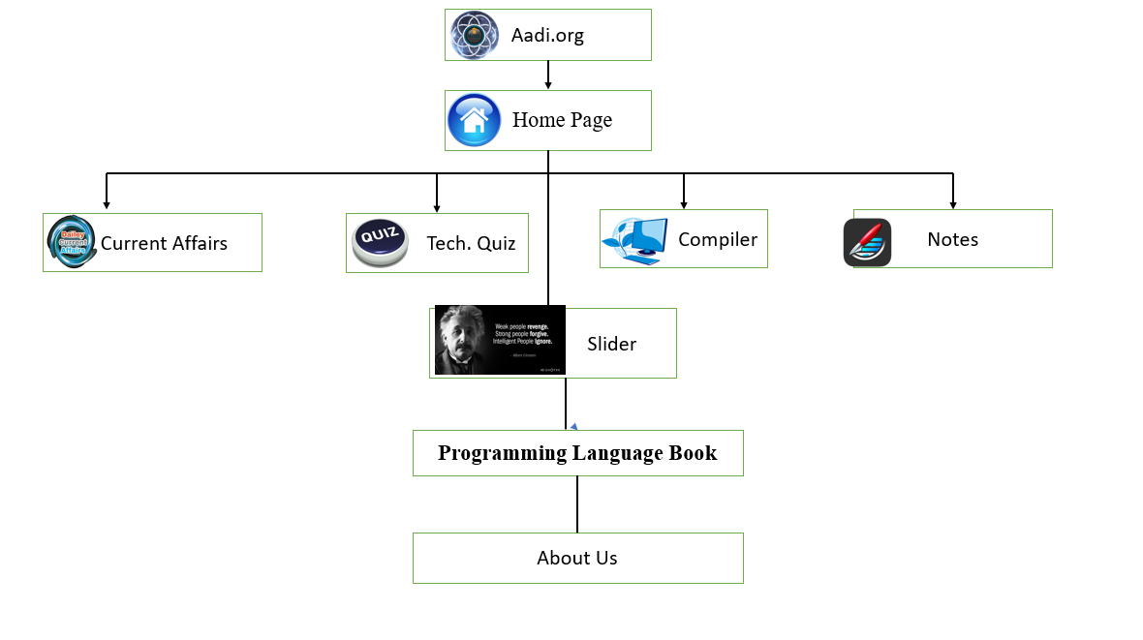**Fig 1:** Block Diagram

* Current Affairs: This section of the site focusses on the latest current affairs, anyone can click on it to read them online or download them in pdf format.
* Tech Quiz: In this section the admin has the facility to create quizzes of his choices, and the other users can attempt it in order to check their capability in the respective domain.
* Compiler: It re directs user to the online compiler to perform coding on various languages, this feature works only when the system is connected to the internet.
* Notes: It allows the user to create notes and save them for future references.
* Slider: Images with various quotes are displaying and changing on their own in a given time period
* Programming Language book: provides various downloadable eBook related to programming
* About Us: tells the user about the main motive of the complete website.

1. **Technology Used**

The objective of this project is to create a learning website for students. To build this project, we need an intermediate understanding of web development .

**HTML5 :** HTML means Hypertext Markup Language. This language is used in creating web pages. It was first released in 1993. This language also supports other languages such CSS, PHP, JAVASCRIPT, etc. in creating interactive and responsive pages on the pages. HTML mainly uses tags and attributes. HTML5 is just an updated version of the HTML.

**CSS3 :** CSS is simply referred to as Cascading Style Sheets. CSS3 was introduced in year 2011 and CSS was introduced in 1994.CSS is used to define styles for web pages, including the design, layout, and variations in the display for different devices and different screen sizes. It is very easy and fast to use and understand.

# JavaScript: JavaScript is a lightweight, cross-platform, single-threaded, and interpreted compiled programming language which is also known as the scripting language for webpages. It is well-known for the development of web pages, and many non-browser environments also use it.

**VS Code:** Visual Studio Code is a source code editor made by Microsoft for windows, Linux and macOS. Features include support for debugging, syntax highlighting, intelligent code completion, snippets, and embedded Git. VS code is a source code editor that can be used with a variety of programming languages.

1. **Requirement and Specifications**

* Processor: Pentium(4)
* Memory: 1GB
* Hard Disk Capacity: 500 GB
* Speed: 1.1GHz
* Network: Internet Connectivity

**References**

* <https://www.irjmets.com/uploadedfiles/paper//issue_5_may_2023/38358/final/fin_irjmets1683608868.pdf>
* <https://www.irjmets.com/uploadedfiles/paper//issue_5_may_2022/25212/final/fin_irjmets1654434678.pdf>
* <https://www.irjmets.com/uploadedfiles/paper//issue_6_june_2023/41598/final/fin_irjmets1686078589.pdf>
* <https://www.learnvern.com/course/html5-tutorial-in-hindi>
* <https://www.w3schools.com/css/default.asp>

**Responsive Blog Website**

by

Group no. 3

Signature…………………………

Name: Deepanshu

Roll No: 2100140100031

**Mr. Hiresh Gupta Mr. Anjali Arora Ms. Anubha Dhaka**

**HOD (CSE) PROJECT INCHARGE SUPERVISOR**



Department of Computer Science and Engineering

**Shri Ram Murti Smarak College of Engineering & Technology, Bareilly**

**Dr. A.P.J. Abdul Kalam Technical University, Lucknow**

15th July, 2023